**RETAIL STORE STOCK INVENTORY ANALYTICS**

**ABSTRACT**

Retail inventory management is the process of ensuring you carry products that shoppers want, with neither too little nor too much on hand. By managing inventory, retailers meet customer demand without running out of stock or carrying excess supply. Inventory management is vital for retailers because the practice helps them increase profits. They are more likely to have enough inventory to capture every possible sale while avoiding overstock because Too much inventory means working capital costs, operational costs, and a complex operation. Based on the inventory management analysis we can manage how much inventory is required for selling the product based on which they can calculate the profit & losses. The objective of this project is twofold. First, it proposes an analytic model for hospital inventory management commodities, which would be able to predict the future demands of various inventory commodities. The model takes into account previous demand, population and geographic Location and other factors to successfully predict the future demand. Second, the project suggests an optimization model that would minimize the cost involved in supply chain & logistics management so that the required commodities can be made available to the hospitals at the minimum possible cost.

As inventory management deals with huge volume and different varieties of information which seems very complex to handle in the daily basis. Inventory stock should be modified or updated based on the customer retention which changes continues with the change in demand which also adds value to the organization in profits by avoiding wastages in the stock. To update the stock data in the organization one should keep on track with the end user demand time to time which can be done by keep track on goods based on First in first out and Last in First Out stock.

**INTRODUCTION**

In recent times, the employment of analytics in the all kinds of business sectors, especially the retail sector has proven to increase success in their daily operations. This project aims to prove that, in addition will identify what factors are actually contributing to this roaring success in the retail sector. Of course, the use of analytics in the business processes has its own pros and cons, but majority of the organizations feel that the introduction of analytics in their business processes has made things easier for them.

Some of the drawbacks of using big data analytics in the retail sector has risen concerns among the customers as well the retailers. Privacy concern is one of them. Customers feel that their privacy are being snatched away when retailers track their location or store their purchase information for targeting them with personalized advertisements. Although big data analytics help employees to fasten up their work, it also poses a high cost for managing such a huge amount of data. Software needed to sort and analyze these data are very expensive. On the other hand, requires skilled people to work with them. Data quality decreases because of automation of data gathering, sorting and analyzing them.

Some major advantages of using big data analytics in the retail sector are it saves costs, helps in product development, speeds up data management, helps in predicting future, helps in inventory management, helps in price management, helps in micro targeting customers, etc.

Overall, the use of analytics decreases the use of man force as it automates all the processes but on the other hand. It helps in product development as analytics can carry out sentiment analysis of a lot of actual and potential customers through social media and find out their preferred types of products, developing their future products accordingly. The use of analytics lets the retailers to predict future demands while analyzing their stocks. Micro targeting the customers can be easy when location of customers can be easily known to the retailers by the use of analytics.

Although there are many cons of adapting big data analytics in business or retail sector, but the pros are more and outweighs all the cons. This aims to prove that.

**EXISTING SYSTEM**

Inventory data management deals with large collection stock related data in the supply chain management environment. The frequency of data collection is very high in terms of stock volume. Content analysis management plays a vital role in managing the stock data in order to classify and cluster in terms managing the data. The process of data classification and clustering will keep track on the stock in order to fulfill the customer need on demand.

The inventory management with respect to supply chain management involves not only controlling the raw materials of stock as well the cost which is related to the stock in the supply chain environment. This process involves in verifying the demand on stock by making use of the concept first in first out(FIFO) and Last in First out(LIFO) techniques in order to verify the demand basis of end user which helps to control the wastages in stock in inventory Management.

The error rate and complexity of huge volume of data is very high. We need some techniques in order to prevent the issues which are directly related to the volume and variety of data in managing the stock information within an organization.

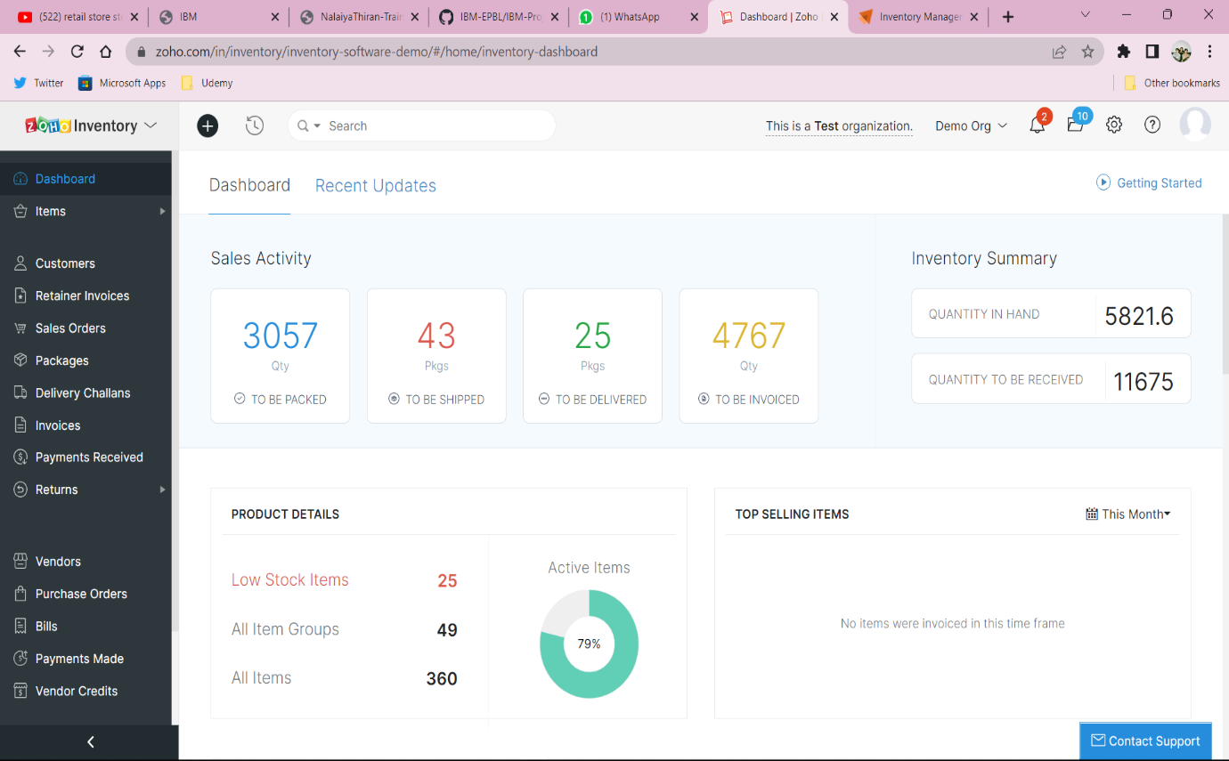

In this approach, supply chain management and inventory data management deals the huge assortment of data in terms of both volume and variety using different dimensions.

1. Data Classification

2. Data clustering

3. Content analysis

4. Customer retention

5. Inventory based on LIFO and FIFO.

Supply chain Management and inventory data management using big data analytics In inventory management, we support to marketing analysis which helps in identifying the stock with in demand with respect to the end user with the change in need. Based on this survey, we can update the stock management with respect to the time and situation of the end user. Analysis of data prediction is based on customer retention which directly related to the end user satisfaction rate.

The increase in data results not only in storage but also in analyzing and processing the flow of information in while classifying and clustering the data as per need. There we come up with a concept of content analysis and management which is major aspect in managing the stock within an organization with raised change in demand.

**DISADVANTAGES OF EXISTING SYSTEM**

* As inventory management has numerous components, clear communication is vital for a seamless flow.
* Better access would improve the efficiency of inventory and other business processes.
* Warehouse management would be vulnerable to errors without integrated software. Inept warehouse management could lead to lost orders, delays in order fulfilment, and errors in shipment.
* Selling more than you can deliver could stain your business’ reputation for a long time.

**REFERENCES**

1. Retail Inventory Management When Records Are Inaccurate Nicole DeHoratius, Adam J. Mersereau, and Linus Schrage The University of Chicago Graduate School of Business 5807 South Woodlawn Ave., Chicago, IL 60637 @ChicagoGSB.edu November 10, 2005.
2. Inventory Record Inaccuracy: An Empirical Analysis Nicole DeHoratius1 and Ananth Raman2 August 2004.
3. Retail Inventory Management with stock-out based dynamic demand substitution : Baris Tan n , Selcuk Karabati College of Administrative Sciences and Economics, Koc- University, Rumeli Feneri Yolu, Sariyer, 34450 Istanbul, Turkey.
4. Inventory Management of a Fast-Fashion Retail Network : Felipe Caro J´er´emie Gallien † August 2, 2007.
5. A Review of Inventory Management Research In Major Logistics Journals Themes and Future Directions : Brent D. Williams Department of Marketing and Logistics, Sam M. Walton College of Business, University of Arkansas, Fayetteville, Arkansas, USA, and Travis Tokar The Ohio State University, Fisher College of Business, Marketing and Logistics, Columbus, Ohio, USA
6. Inventory management in retail industry - Application of big data analytics : Hien Vu – ID: 869211121
7. Predictive Analysis of Big Data in Retail Industry Literature Review Hamza Belrari1, Abdelali Tajmouti1 1 lmeet, FST of Settat, Hassan 1st University Settat, Morocco hamzabelarbi@gmail.com Hamid Bennis , Mohammed el haj tirari 2 lmeet, FPK/FST of Settat, Hassan 1st University Settat, Morocco 3 INSEA, Rabat, Morocco.
8. A Model Proposal for Big Data Analytics in the Retail Sector of Bangladesh : Ahmed Imran Kabir*, Faiza Tabassum, Jakowan and Rifat Afrin, School of Business and Economics, United International University, Bangladesh ,Copyright @ 2021.
9. Contemporary Supply Chain and Inventory Data Management Using Data Analytics : Dr. S. Sai Satyanarayana Reddy, Ch. Mamatha, Priyadarshini Chatterjee and S Nagarjuna Reddy Department of Computer Science and Engineering; Department of Information Technology, Vardhaman College of Engineering, Hyderabad, India.
10. Optimal Health Care Inventory Management Using Analytics Neeraj Agrawal Prakarsh Paritosh Ashish Paralikar Dibyajyoti Pati General Electric JFWTC, 122 EPIP Bangalore, India 560066.
11. Lin, D.C., and Yao, J.S. (2000). Fuzzy Economic Production for Production Inventory. Fuzzy Sets and Systems, 111(3): 465–495.
12. Wagner, H.M. (1980). Research Portfolio for Inventory Management and Production Planning Systems. Operation Research, 28(3): 445–475.